12.Demonstrate random and random order controllers in JMeter.

* Random Controller : loop count = 3
* ====================
* pre-condition -login -> test3 -> postcondition - login
* pre-condition -login -> test1 -> postcondition - login
* pre-condition -login -> test2 -> postcondition - login

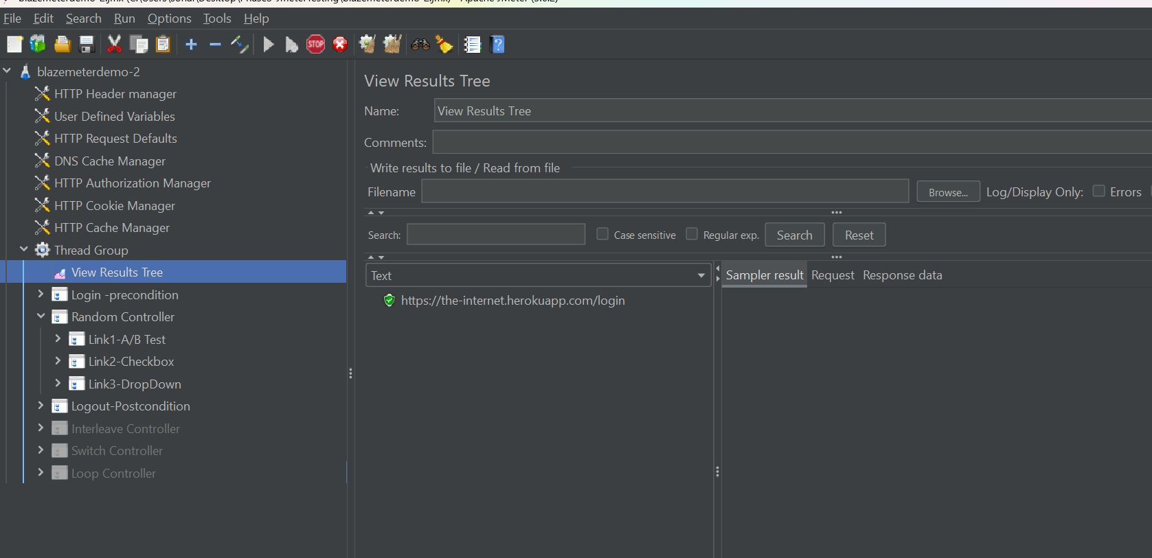

* Random order controller:
* ================================
* pre-condition -login -> test3, tes1, test2 -> postcondition - login
* pre-condition -login -> test1, tes3, test2 -> postcondition - login
* pre-condition -login -> test3, tes2, test1 -> postcondition - login

